**Spark XML Processing:**

**Tools Used: ( HDFS, Spark Sql, SBT)**

Databricks providing a library for parsing and querying XML data with Apache Spark, for Spark SQL and DataFrames. The structure and test tools are mostly copied from [CSV Data Source for Spark](https://github.com/databricks/spark-csv).

This package supports to process format-free XML files in a distributed way, unlike JSON datasource in Spark restricts in-line JSON format.

**Example:**

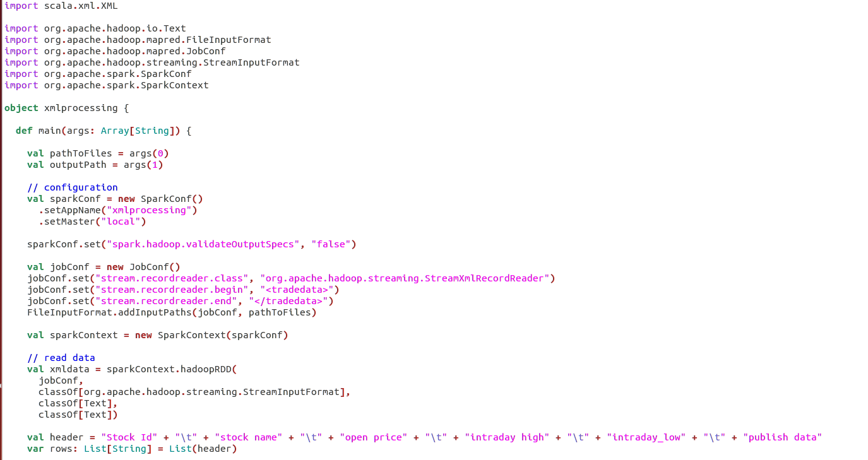

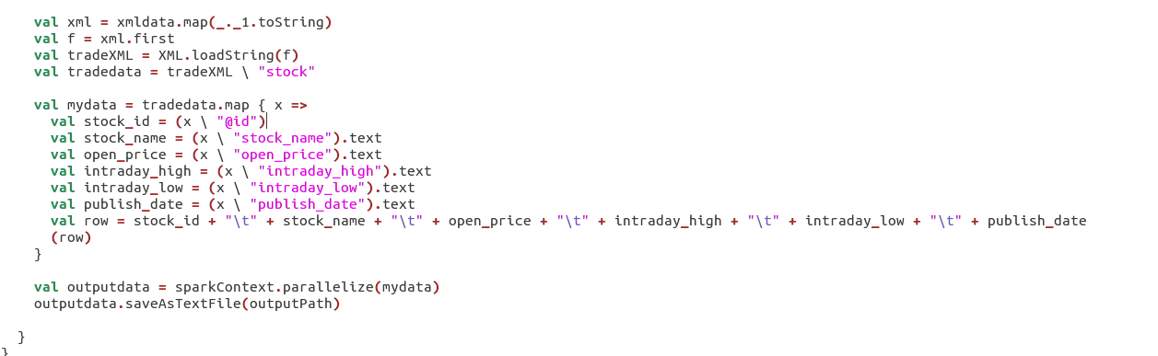

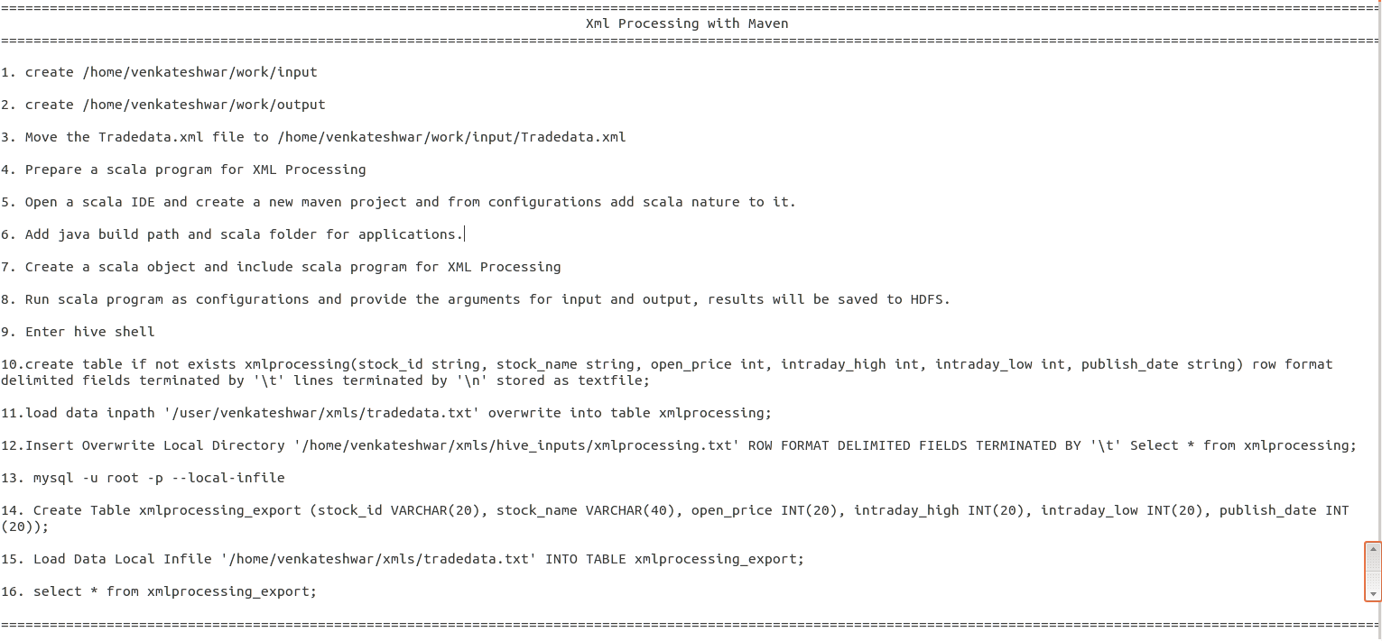

as